**ASSIGNMENT 2**

ROLL NO : 727619BIT050

NAME : GUNADESHWAR A

1. 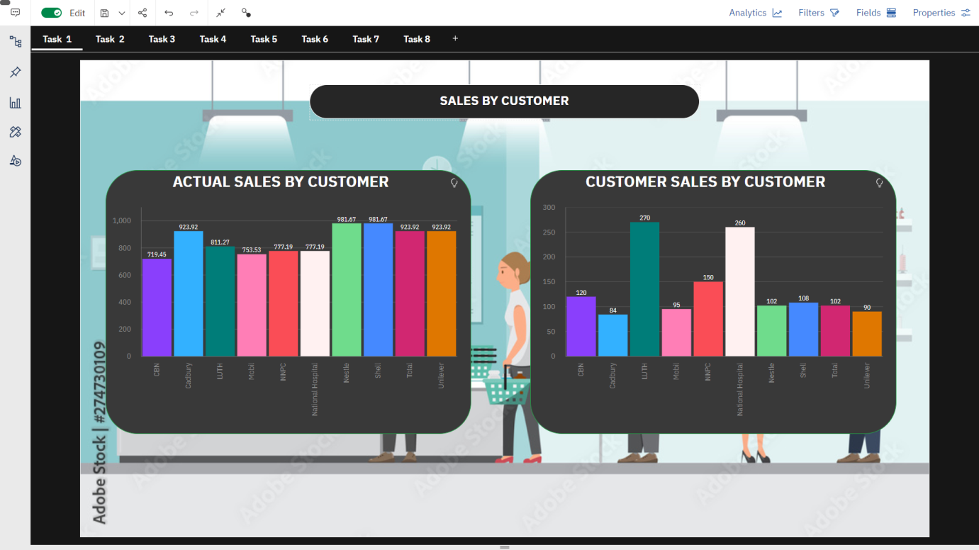SALES BY CUSTOMER
2. SALES BY LOCATION



1. SALES BY SALES REPRESENTATIVE

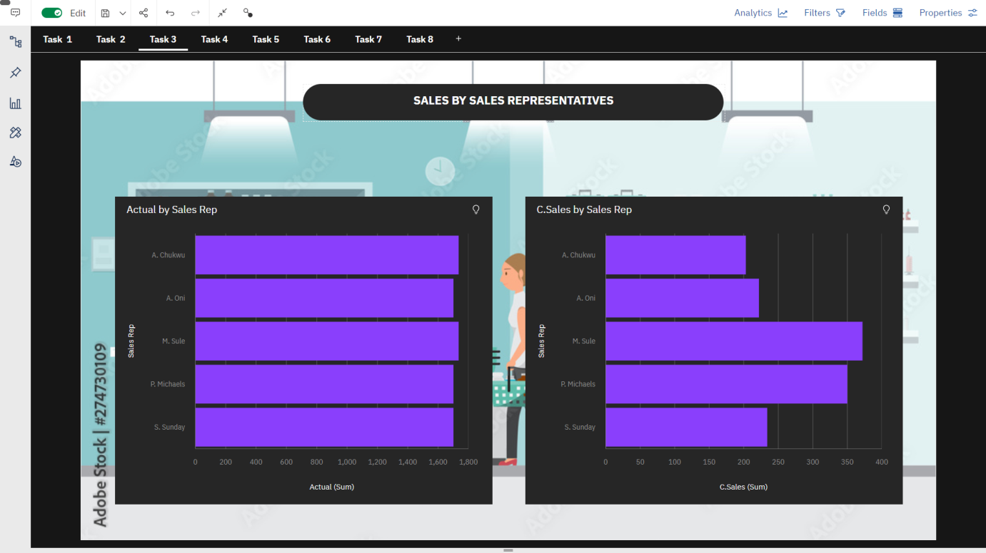

1. 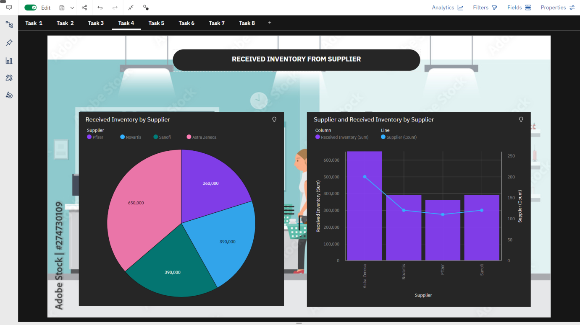RECEIVED INVENTORY FROM SUPPLIER
2. INVENTORY STOCK FOR WAREHOUSE LOCATIONS

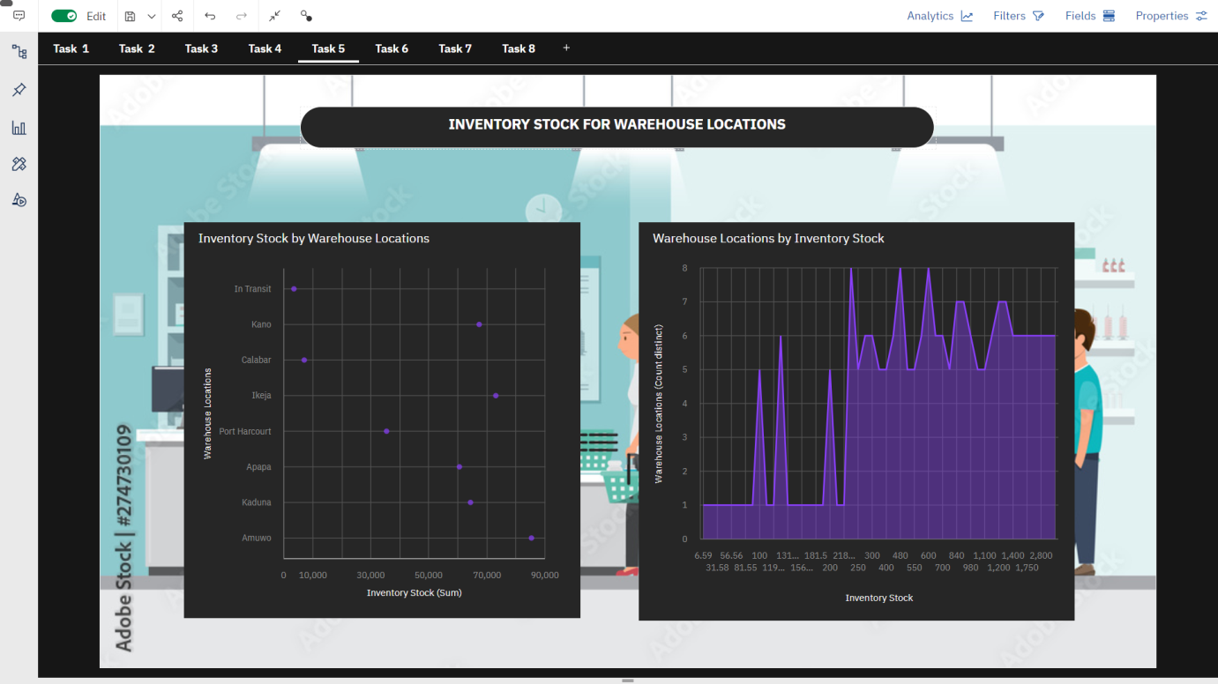

1. SALES TREND
2. 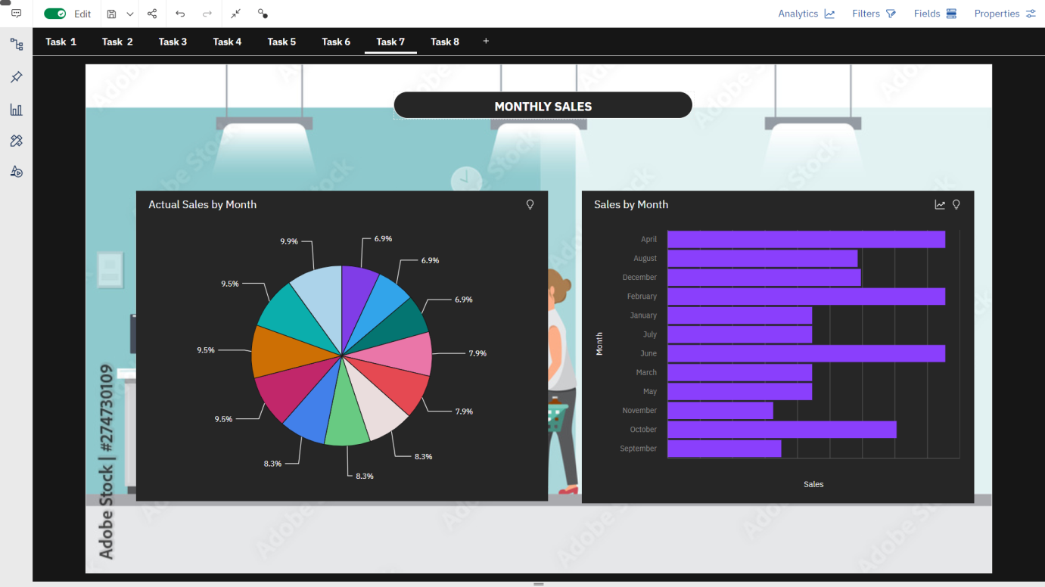MONTHLY SALES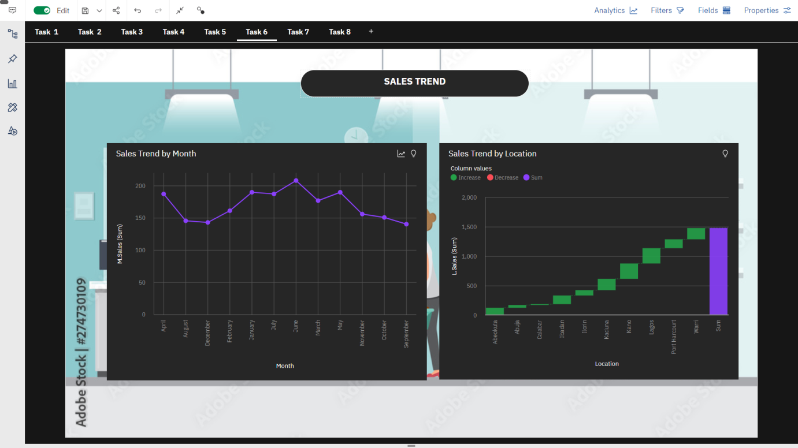
3. ACTUAL AND RECEIVED INVENTORY BY MONTH

